## 2. More Information about Users

In addition to the obtained information about users using GitHub API, the number of stars and achievements by 10 users are presented in Table 1.

Table 1. The number of stars and varieties of achievements of 10 users.

|  |  |  |  |  |  |  |  |
| --- | --- | --- | --- | --- | --- | --- | --- |
| **S/No.** | **User ID** | **Stars** | **Achievements** | | | | |
| **YOLO** | **Artic Code Vault Contributor** | **Pull Shark** | **Starstruck** | **Others** |
| 1. | erinata | 18 | 0 | 1 | 1 | 2 | 0 |
| 2. | voodootikigod | 125 | 1 | 1 | 3 | 3 | 0 |
| 3. | piclez | 981 | 1 | 0 | 3 | 0 | 0 |
| 4. | brianleroux | 413 | 0 | 1 | 2 | 3 | 0 |
| 5. | clarkbw | 660 | 0 | 1 | 3 | 2 | 1 |
| 6. | frozzare | 5k+ | 1 | 1 | 3 | 2 | 2 |
| 7. | ssleptsov | 180 | 0 | 0 | 0 | 0 | 0 |
| 8. | robinwu | 314 | 0 | 0 | 1 | 0 | 0 |
| 9. | liangwenke | 296 | 0 | 0 | 0 | 1 | 0 |
| 10. | caingougou | 1700 | 0 | 1 | 0 | 0 | 0 |

## 3. Summary Statistics and Plots

Based on the data of 524 users, the average number of followers is 416.37. The average number of following is 3874.45, while the average number of repositories per user is 139.16.

Figure 1. Summary statistics for the number of followers, following count, and number of public repositories

To explore the relationships between the number of following and followers as well as the number of repositories and followers, a scatterplot of the logs was plotted and presented in Figure 2. The plot shows an almost linear relationship between following and followers. A higher number of following was largely related to a higher number of followers. One possible reason for this is reciprocal followership. Users would often follow back who follows them. This means the more a user follows other users, the user gets followed back by many of the users.

The relationship between the number of repositories and the number of followers, on the other hand, is not so clear-cut. There are instances where users with few repositories had a large number of followers. This suggests that having many repositories does not necessarily correlate with gaining many followers.

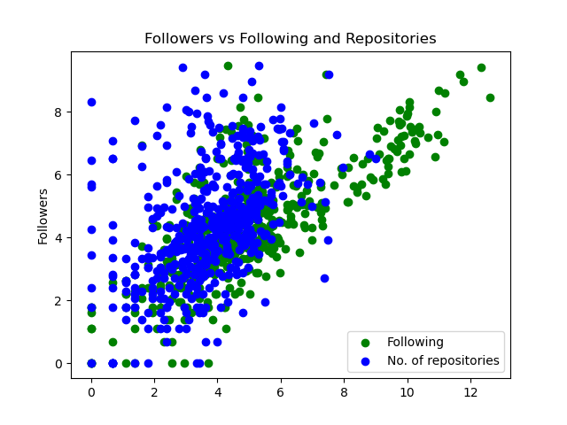

Figure 2. Scatterplot of followers vs following and number of repositories